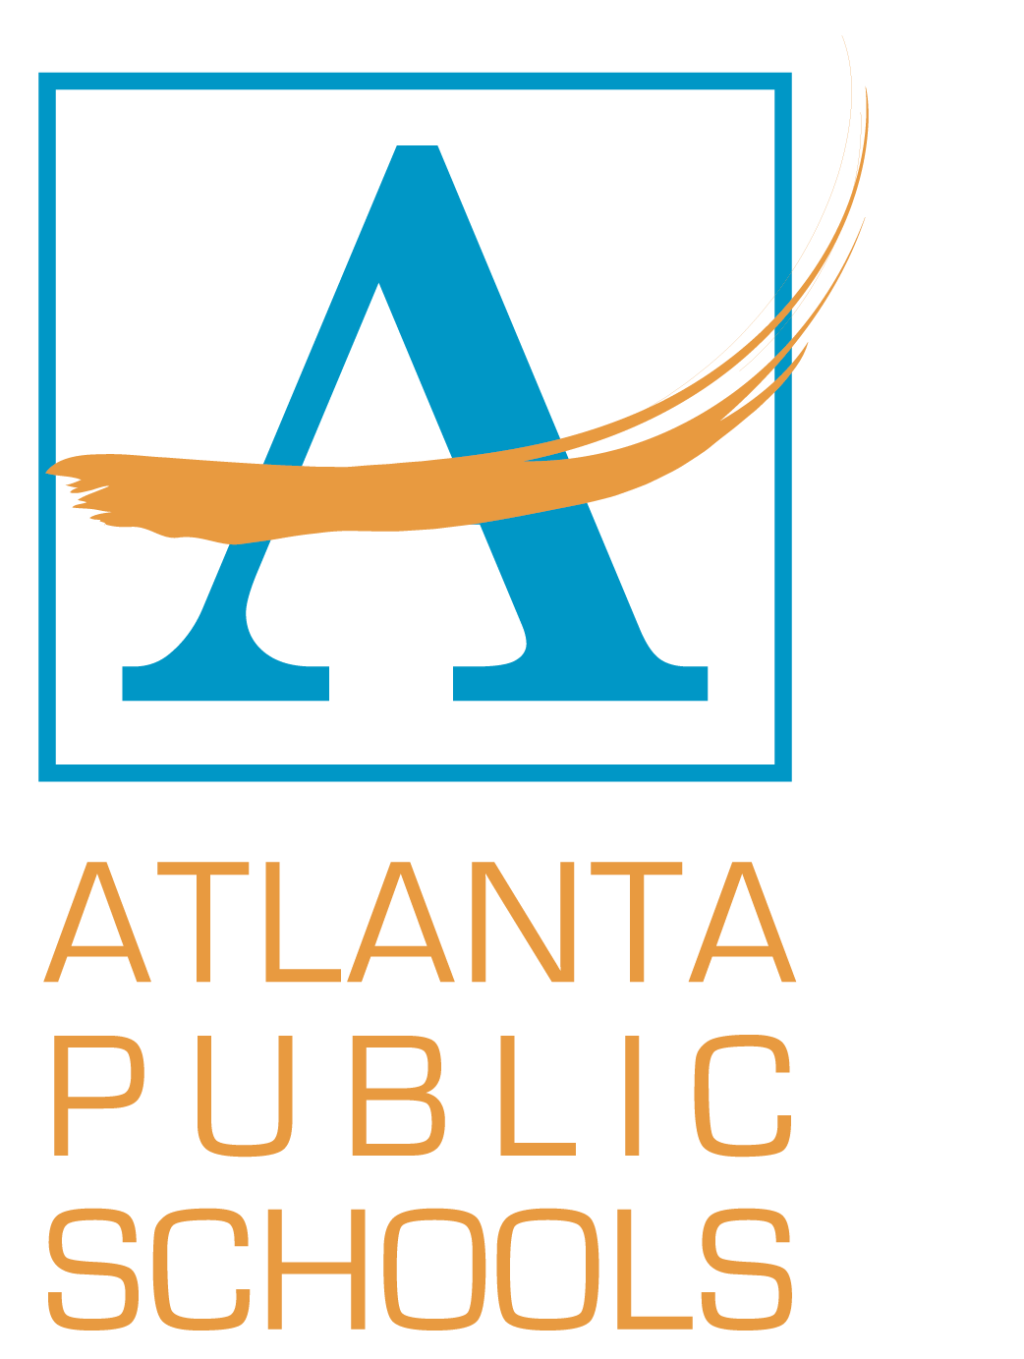
Atlanta Public School Promotion Policy
To participate in any graduation exercises or ceremonies, Atlanta Public Schools seniors must meet all requirements for a regular education diploma or a special education diploma. Students enrolled in Programs for Exceptional Children (PEC) whose individualized Education Programs (IEP) indicate that they are unable to meet these requirements shall be allowed to participate in graduation exercises and ceremonies.

